**Deploying .NET Core Web API to Azure Portal**

1. Open the ASP.NET Core Web api project in VS Code.
2. Open the integrated terminal and type the following command to generate the publish files for deployment.

“**dotnet publish -f <version>**”

Eg: **dotnet publish -f netcoreapp1.1**

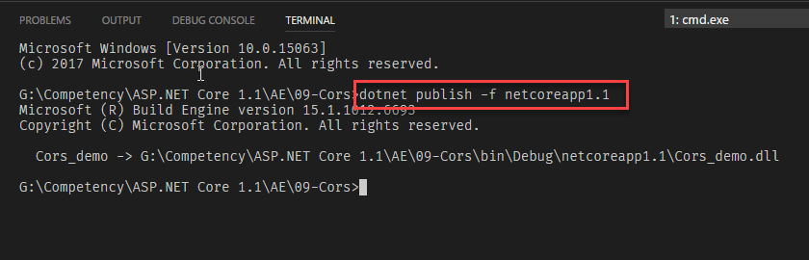

1. Your deployment files will be published inside the **bin** folder.

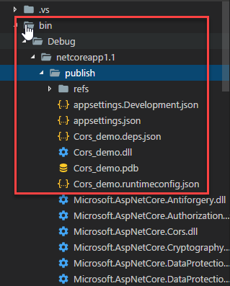

1. You can deploy the files, which is located in the publish folder into your Azure web app.
2. To deploy the files on azure, Open the Azure Portal by navigating to <http://portal.azure.com>.
3. Create a new Web Apps by clicking New > web+Mobile > Web Apps.

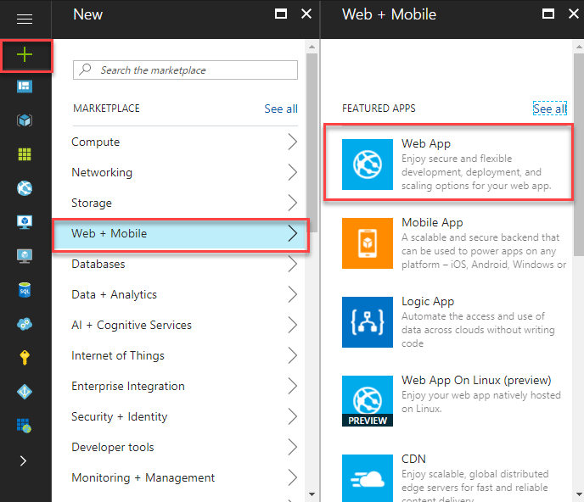

1. Enter the name, location and Service plan for the web apps.

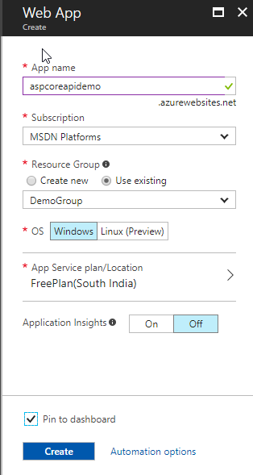

1. We need to set the deployment credentials for FTP. For that you need to click the ‘deployment credentials’ from the settings blade and enter the username and password, Click to save the details.

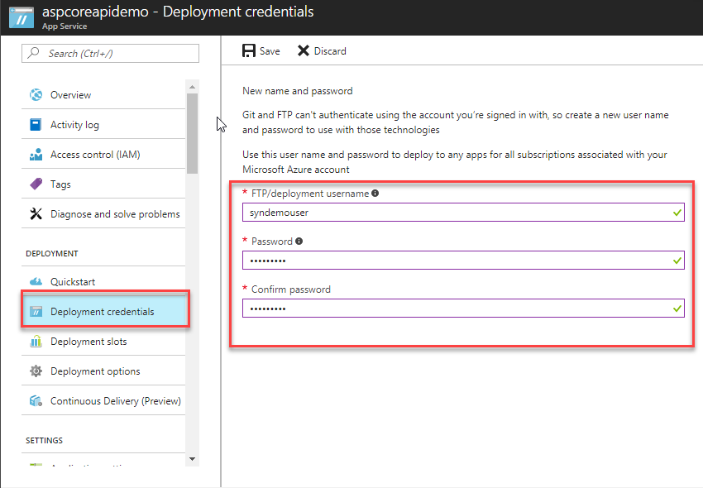

1. Now you need to publish your files on azure web app. For that download the Publish profile from the Application Dashboard.

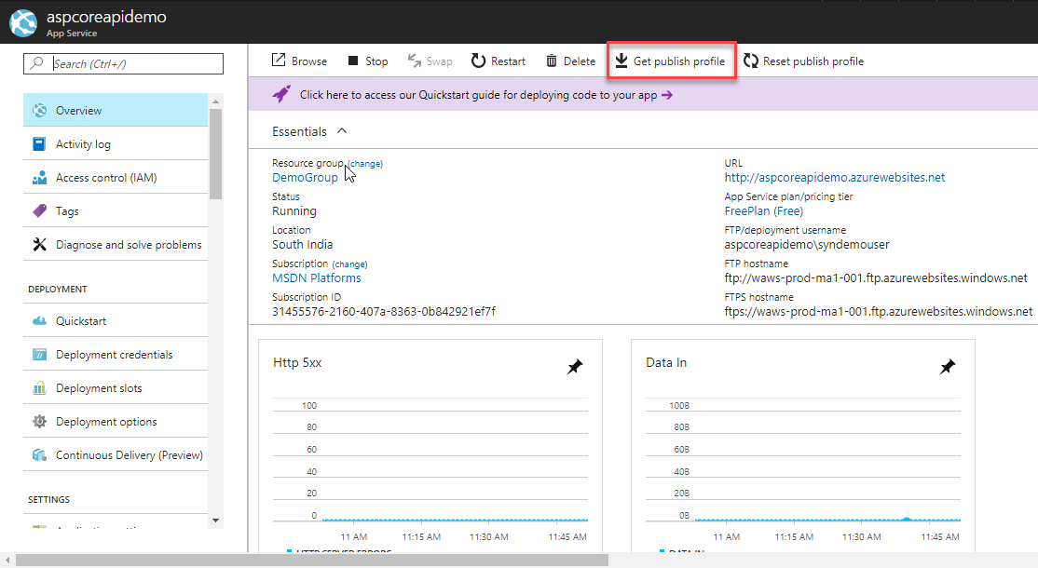

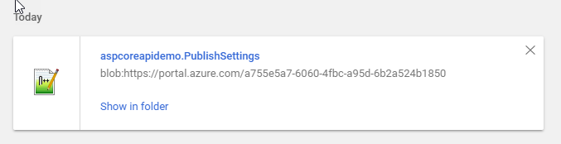

1. Open the downloaded publish profile in NotePad or any other text editor.

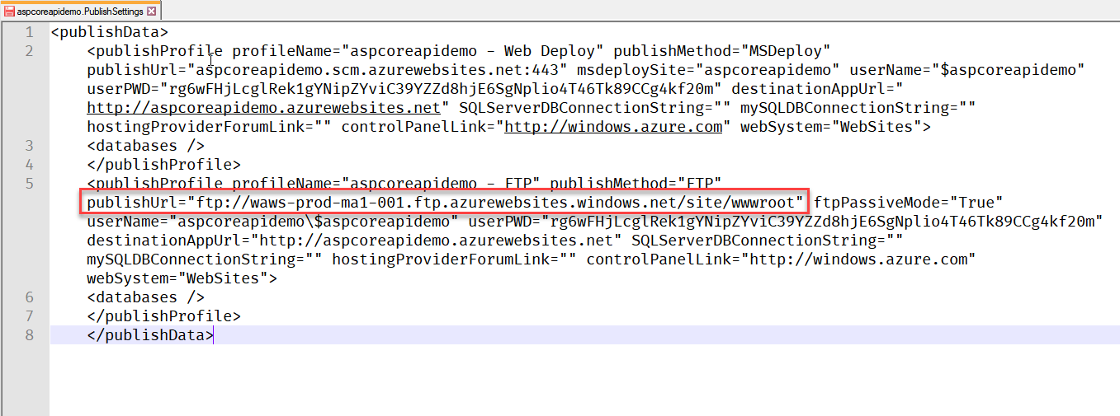

1. Copy the FTP publish URL into windows explorer (or any FTP client) and press enter. It prompts for the username and password. Enter the user name in the following format “<webappname>/<ftp deployment username>”. The FTP username you can use the one which you have saved in the deployment credentials window.

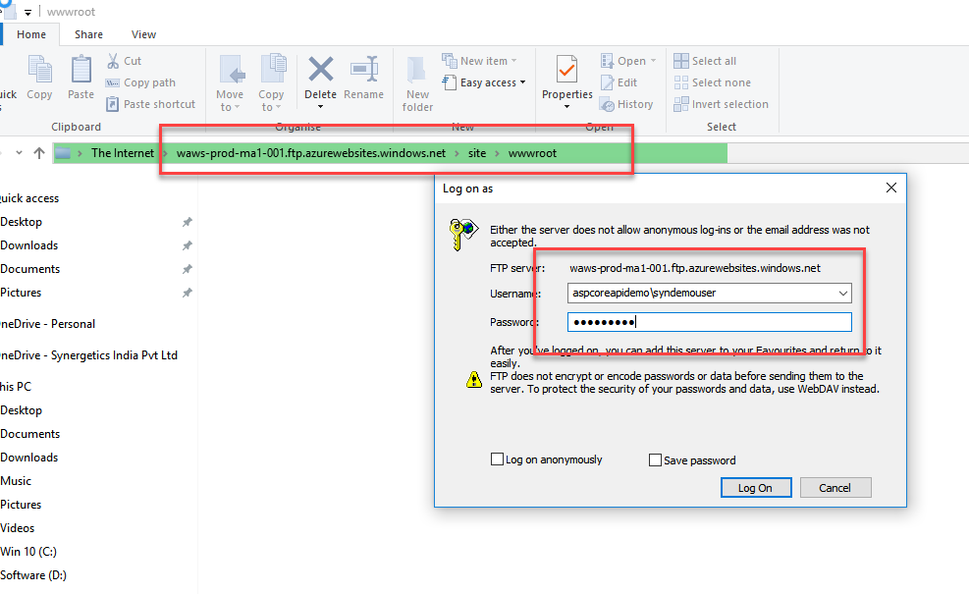

1. It opens the **wwwroot** folder. You can copy the published files from the application to the **wwwroot** folder.
2. Once you have completed the copy process, go back to the Azure portal and click on the application url.

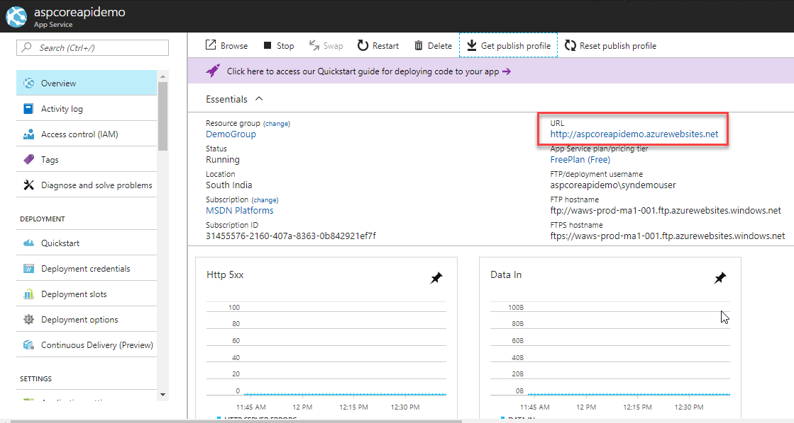

1. Navigate to the swagger documentation page.

